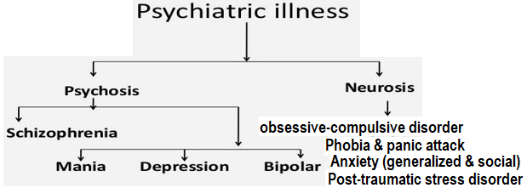
Neurosis | Psychosis
Insight is presentالبصيرة او القدرة علي فهم الحالة | Insight is absent
Reasoningالمنطق &Judgment is intact | Judgment & reasoning is impaired
Reality contact is present | Reality contact is lost
Delusion are absent | Delusion are present
True hallucinations are usually absent | True hallucinations are usually present
Change in personality is usually absent | Change in personality is usually present
Treatment mainly by psychological method NO need for hospitalization | Treatment mainly by physical method and need for hospitalization
Major depressive disorder (MDD):
Women have a higher risk of depression than men from early adolescence until their mid-50s, with a lifetime rate that is 1.7 to 2.7 times greater
Although depression can occur at any age, adults 18 to 29 years of age experience the highest rates of major depression during any given year
Etiology
Causes and risk factors:
The exact cause is unknown, but variety of factors may be involved:
A. Genetic Factor
Depressive disorders and suicide tend to occur within families. For example, approximately 8% to
18% of patients with major depression have at least one first-degree relative
B. Environmental and psychological Factor:
Loneliness, lack of social support, recent stressful life experiences; marital or relation problems, financial strain, early childhood trauma or abuse, unemployment and alcohol or drug abuse.
C. Biological Factor:
1. Neuroendocrine hypothesis:
Approximately 45% to 60% of patients with major depression have a neuroendocrine abnormality, including hyper-secretion of cortisol or a lack of cortisol suppression after dexamethasone administration (i.e., a positive dexamethasone suppression test). In fact, it has been suggested that the inability of the brain to suppress the hypothalamic-pituitary-adrenal (HPA) axis and the associated stress response could lead to the pathophysiology and symptoms of depression. According to this theory, there is a disruption somewhere in the normal negative feedback system that controls cortisol levels. Unfortunately, the high rate of false-positive and false-negative results associated with neuroendocrine abnormalities in depressed patients limits the usefulness of testing for biological markers and has led to their relative lack of use in clinical practice. However, they still provide a clue to the potential pathophysiology of depressive disorders, which may lead us to more effective treatment options
2. neurotrophin hypothesis:
Brain-derived neurotrophic factor decreased in depressed & suicidal behavior patients. This has led to the proposal of the “neurotrophin hypothesis of depression”
Brain-derived neurotrophic factor (BDNF) is a member of the neurotrophin family of growth factors protein plays an important role in
differentiation, maturation, and survival of neurons in the nervous system
neurogenesis: stimulates and controls growth of new neurons from neural stem cells
vital to learning, long-term memory and higher thinking
neuroprotective effect under adverse conditions, such as glutamatergic stimulation, cerebral ischemia, hypoglycemia, and neurotoxicity
suppresses energy intake and reduces body weight
The possible relation between Neuroendocrine hypothesis and neurotrophin hypothesis
There are many potential negative consequences of excess circulating cortisol, including disruption in Brain-derived neurotrophic factor expression.
More specifically, chronic stress and an associated increase in glucocorticoids such as cortisol may cause a disruption of Brain-derived neurotrophic factor expression in the hippocampus. This process may be prevented, or possibly even reversed, by antidepressant medications
Low Brain-derived neurotrophic factor level may be responsible for loss of mono-aminergic neurons and loss of function or atrophy of hippocampus and prefrontal cortex.

Loss of hippocampus ability to inhibit the release of corticotropin-releasing factor (CRF) by hypothalamus (dis-regulation of hypothalamic-pituitary-adrenal axis)

Increase the release of glucocorticoid
This relatively recent theory has not been firmly established; however, if validated,
It will demonstrate that antidepressants may help prevent deleterious effects of chronic stress and depressive symptoms.
It highlights the fact that antidepressants may work by a mechanism that is not yet evident at this time, as we continue to learn more about the complexities of major depression and its treatment.
3. Biogenic mono-amine hypothesis
Multiple reports show a direct correlation between chronic stress and depression with
a. decreased volume, synaptic atrophy/loss, and altered connectivity
b. decreased neurotransmitters (NTs), specifically norepinephrine (NE), serotonin (5-HT), and dopamine (DA)
In the prefrontal cortex and limbic system
In the early 1950s; it was noted that the antihypertensive drug reserpine depleted neuronal storage granules of NE, 5-HT, and DA and produced clinically significant depression in 15% or more of patients.
Although the reuptake blockade of monoamines (e.g. NE, DA, and 5-HT) occurs immediately on administration of an antidepressant, the clinical antidepressant effects (i.e. measurable improvement) are generally delayed by weeks.
There are many theories provides a cogent explanation شرح مقنعof the delayed onset of therapeutic response of antidepressant drugs
a. Adaptive (or chronic) changes in amine receptor systems theory
Studies of many antidepressants have demonstrated that
Desensitization or down-regulation of β-adrenergic receptors
Desensitization of presynaptic 5-HT_{1A} auto-receptors
b. The dys-regulation in amine receptor systems theory
According to this hypothesis, effective antidepressant agents restore efficient regulation to the dys-regulated (i.e. failure of homeostatic regulation) of amine receptor systems system rather than on absolute increases or decreases in their activities
c. The serotonergic and noradrenergic systems link theory
According to this hypothesis,
there is a link between serotonergic and noradrenergic systems
both the serotonergic and noradrenergic systems are involved in an anti-depressant response.
both serotonergic and noradrenergic medications down-regulate β-adrenergic receptors, and.
The medications that are effective in the treatment of depression act at serotonergic and noradrenergic systems
d. The Dopaminergic systems link theory
Traditional explanations of the biologic basis of depressive disorders have focused largely on NE and
5-HT; however, most of the evidence that coalesced into the biogenic amine hypothesis of depression does not clearly distinguish between NE and DA. There is an abundance of evidence suggesting that DA transmission is decreased in depression and that agents that increase dopaminergic transmission have been found to be effective antidepressants. Specifically, studies suggest that increased DA transmission in the mesolimbic pathway accounts for at least part of the mechanism of action of antidepressant medications. The mechanisms by which antidepressant drugs alter DA transmission remain unclear but may be mediated either directly by dopaminergic changes or indirectly by primary actions at NE or 5-HT terminals.
The complexity of the interaction between 5-HT, NE, and DA is gaining greater appreciation, but a more in-depth understanding of the precise mechanism is needed. Furthermore, the availability of dopaminergic-based first-line and augmentation antidepressant strategies has been slowly growing e.g.
bupropion: norepinephrine–dopamine reuptake inhibitor,
venlafaxine” serotonin–norepinephrine–dopamine reuptake inhibitor,
aripiprazole, and most recently brexpiprazole "serotonin–dopamine activity modulator"
e. GABAergic deficit/imbalance hypothesis of depression
Accumulating evidence suggests that MDD and chronic stress are associated with an imbalance of excitation–inhibition (E:I) within the prefrontal cortex, generated by a deficit of inhibitory synaptic transmission onto principal glutamatergic neurons.
MDD patients and chronically stressed animals show
a reduction in GABA due to a reduction in due to a reduction in glutamic acid decarboxylase 67; GAD67
Glutamate decarboxylase or glutamic acid decarboxylase (GAD) is an enzyme that catalyzes the decarboxylation of glutamate to GABA and CO2
glutamic acid decarboxylase exists in two isoforms with molecular weights of 67 and 65 kDa (GAD67 and GAD65), these two enzymes maintain the major physiological supply of GABA in mammals’ levels in the brain
decreased expression, and alterations in GABA_{A} & GABA_{B} receptor levels
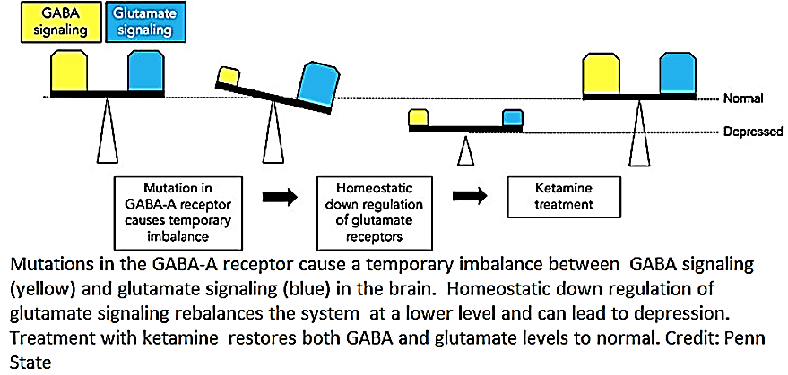
Ketamine is an N–methyl-D aspartate receptor antagonist has a robust and rapid effect on depression, which was seen immediately after the administration of ketamine
Diagnostic Criteria for Major Depressive Episode
A.
Five (or more) of the following symptoms at least one of the symptoms is either
(1) depressed mood or
(2) loss of interest or pleasure.
have been present during the same 2-week period and represent a change from previous functioning;
Note: Do not include symptoms that are clearly attributable to another medical condition.
1. Depressed mood most of the day, nearly every day, as indicated by either
subjective report (e.g., feels sad, empty, and hopelessالشعور ب الحزن و الخواء و اليأس ) or
observation made by others (e.g., appears tearful or about to cryعلامات الحزن وكأنه ينكي بادية على الوجه).
2. Markedly diminished interest or pleasure (No interest in hobbies, sports, or other things the person used to enjoy doing)
in all, or almost all, activities most of the day, nearly every day,
as indicated by either
subjective account هو يقول ان لاشيء يسعده لا مشاهدة الافلام ولا القراءة ولا الذهاب الى الجم اوممارسة الرياضة
observation made by others اصدقاء يلاحضون انهم كلما يطلبون من الذهاب معهم الى الكافيه او الملعب يرفض
3. Significant
weight loss or weight gain (e.g., a change of more than 5% of body weight in a month)
where when not dieting or decrease or increase in appetite nearly every day.
4. Insomnia or hypersomnia nearly every day
5. Psychomotor agitation or retardation
nearly every-day
observable by others, not merely subjective
Psychomotor: refers to the connections made between mental and muscle functions.
Psychomotor retardation:
observable by others: slowing down of thought (shopping, house upkeep, and money management) & speech, slowing of emotional reactions, reduction of physical movements everyday tasks, such as: brushing teeth, getting dressed, cooking and eating
subjective: grabbing objects or walking may prove difficult. Walking upstairs might be impossible
psychomotor agitation, restless symptoms,
observable by others: skin picking قرص الجلدor pacing around the room يسير في جميع أنحاء الغرفة, desperate to find a comfortable position that are caused by what may be described as mental tension (feelings of restlessness)
subjective: wring their hands, tap their fingers & feet, fidgetتململ, start and stop tasks abruptly,
take off clothes then put them back on
6. Fatigue or loss of energy nearly every day.
7. Feelings of worthlessness الشعور ب الدناءة
excessive or inappropriate guilt (which may be delusional) المبالغة ب الشعور ب الذنب(e.g., ruminating over minor past failing(أجترار اخطاء الماضي البسيطة guilt about being sick
nearly every day
8. Diminished ability to think or concentrate, or indecisiveness
عدم القدرة على التفكير او التركيز مع كثرة التردد
nearly every day
9. Recurrent thoughts of death (not just fear of dying),
recurrent suicidal ideation without a specific plan,
suicide attempt
specific plan for committing suicide.
B. The symptoms cause clinically significant distress or impairment in social, occupational, or other important areas of functioning.
ان تؤدي الاعراض السريرية الى اخلال بالعلاقات الاجتماعية و الوضيفية
C. The episode is not attributable to the physiological effects of a substance or to another medical condition.
ان تكون الاعراض السريرية ليست بسبب استعمال الادوية ولا بسبب امراض طبية
Note: Criteria A-C represent a major depressive episode.
Schizophrenia
Clinical Presentation of Schizophrenia
General
1. Schizophrenia is a chronic disorder of thought and affects التاثير, causing a significant disturbance in the individual’s ability to function vocationallyمهنياand interpersonally.
A. People with schizophrenia may appear uncooperative غير متعاون, suspiciousشكوك, hostile عُدْوانِي, anxious مُشَوَّشُ الذِّهْن, or aggressive حادُّ الطَّبْع due to their misinterpretation تَحْرِيف of reality.
B. They may have poor hygiene and appear dirty unkempt أشْعَث, stained crumple clothes as psychosis as well as depressive symptoms, may lead to impaired self-care.
C. Sleep and appetite are often disturbed.
D. People with schizophrenia often have difficulty living independently in the community and have difficulty forming close relationships with others.
E. They have problems with initiating or maintaining employment.
F. Comorbid medical disorders, such as type 2 diabetes and chronic obstructive pulmonary disease, are prevalent in schizophrenia due to sedentary lifestyles, poor dietary habits leading to obesity, and/or heavy cigarette smoking. Approximately 85% of people with schizophrenia smoke, and approximately 50% use drugs and alcohol, rates that are much higher than in the general population.
2. The onset of symptoms in most cases is insidious غادر, usually preceded by a prodromal البادري phase characterized by gradual social withdrawal, diminished interests, changes in appearance and hygiene, changes in cognition, and bizarre or odd behaviors.
Symptoms
Hallmark symptoms include psychotic symptoms, negative symptoms, and cognitive impairments that last for at least 6 months.
A. Psychotic symptoms:
These symptoms are sometimes called positive symptoms, as they are “added on to” or “Behaviors that are present that should not present” a person’s normal experience. They may include:
1. Hallucinations (distortions or exaggeration of perception)
Hallucinations are false or distorted sensory experiences that appear to be real perceptions. These sensory impressions are generated by the mind rather than by any external stimuli, and may be seen, heard, felt, and even smelled or tasted. They can include:
Auditory hallucinations: voices” are the most common type of hallucination. The voices may
a. talk to the person about their behavior,
b. commanding (i.e., commanding the person to perform a particular action).
c. threatening or warn them of apparent danger.
Patients may feel compelled to perform the commanded task or may experience much anxiety when they do not.
visual hallucinations (e.g., recognizable objects or unformed lights or shadows)
olfactory hallucinations (e.g. unpleasant odors)
tactile hallucinations (e.g., feeling that someone is touching you when no one is nearby)
Tactile, olfactory, and gustatory hallucinations are often believed to be rare in primary psychotic illness.
2. Delusions الاوهام (fixed false beliefs)
Delusions frequently involve fixed false beliefs despite invalidating evidence and may be bizarre in nature. 90% of people with schizophrenia experience delusions
delusions of control (e.g., her thoughts, actions, and bodily movements as controlled by someone)
delusions of reference (e.g., believing someone on TV is talking specifically to you)
erotomaniac delusions (e.g., believing Brad Pitt or Angelina Jolie is in love with you)
grandiose delusions (e.g., believing one is a billionaire who owns all hotels in the city)
persecutory delusions or Paranoid delusions (e.g., believing ones is being followed or try to hurt them or harassed by CIA)
Paranoia feeling extremely nervous and worried because you believe that other people do not like you or are trying to harm you
Paranoia is thinking and feeling like you are being threatened in some way, even if there is no evidence, or very little evidence, that you are. Paranoid thoughts can also be described as delusions.
somatic delusions (e.g., believing one’s nose is infested by worms)
3. Disorganized (or illogical) speech/thinking, also described as “thought disorder” or “loosening of associations,” is a key aspect of schizophrenia.
Disorganized thinking is usually assessed primarily based on the person’s speech.
Thought disorders - illogical thought & speech that can include:
alogia/poverty of content - impoverished speech قلت الكلام& thinking (very little information conveyed by speech)
thought blocking - a sudden losing train of thought, abrupt interruption in speech
word salad - words strung together nonsensically
perseveration - repeating words or ideas persistently
Thinking and speech may be incomprehensible غامض and illogical, silliness and laughter that is not related to content of speech
Subtle حاضِرُ البَدِيهَة, فاطِن disturbances in associative thinking may develop years before disorganized thinking (formal thought disorder).
4. Grossly disorganized behavior includes difficulty in goal-directed behavior (leading to difficulties in activities in daily living), unpredictable agitation or silliness, social disinhibition, or behaviors that are bizarre to onlookers. Their purposelessness distinguishes them from unusual behavior prompted by delusional beliefs.
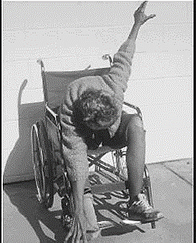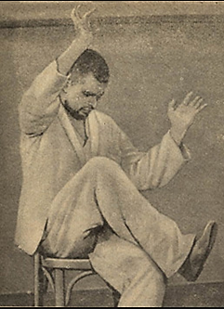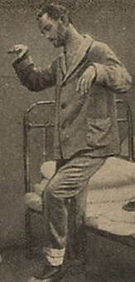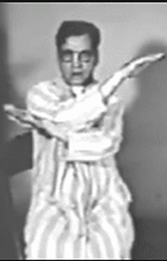
5. Catatonic behaviors are characterized by a marked decrease in reaction to the immediate surrounding environment, sometimes taking the form of motionless and apparent unawareness, rigid or bizarre postures, or aimless excess motor activity
B. Negative symptoms or deficit symptoms:
Symptoms “taken away” from a patient’s personality.
People with negative symptoms often neglect basic personal hygiene and need help with everyday tasks. Specific examples of negative symptoms include:
Affective Flatteningانعدام العاطفة - decrease in the intensity of emotional expression, apathy
Avolition انعدام الارادة- decrease in initiation of goal-directed behavior
Anhedoniaانعدام التلذذ - lack of pleasure in activities normally found enjoyable, or social interactions
Approximately 10% to 15% of people with schizophrenia may present primarily with negative symptoms; these people may be referred to as having a deficit syndrome.
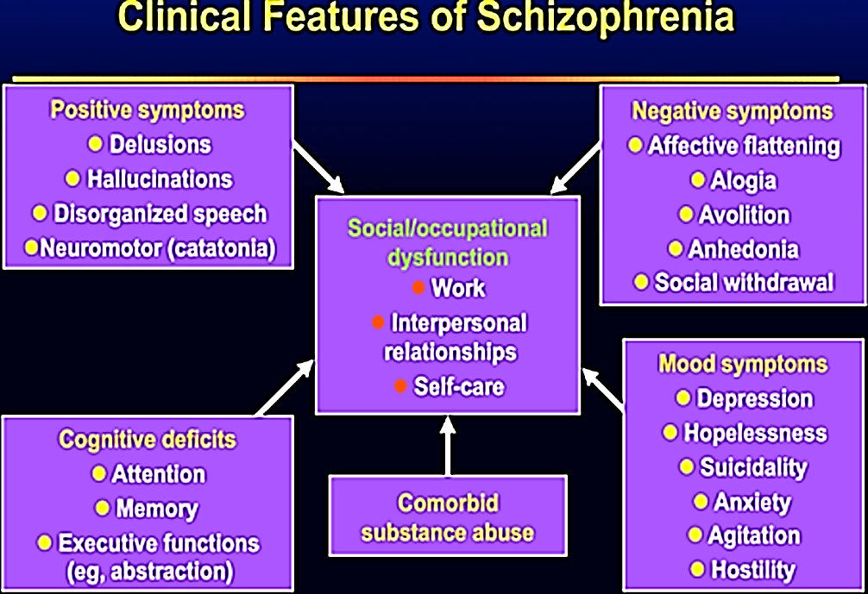

C. Cognitive symptoms:
Cognitive symptoms can be subtle and may only be detected when tests are performed.
They include:
Decreased declarative and working memory
Trouble focusing, understanding, concentration or paying attention
Abnormalities in the areas of processing speed, problem solving, executive function, thinking (slow)
difficulty integrating thoughts, feelings and behavior
There is a loss of, on average, one standard deviation of pre-illness IQ (Intelligence Quotient) with the average IQ of between 80 and 84 (normally 50% of IQ scores fall between 90 and 110).
D. Social/occupational dysfunction:
For a significant portion of the time since the onset of the disturbance, one or more major areas of functioning such as work, interpersonal relations, or self-care are markedly below the level achieved prior to onset (or when onset is in childhood or adolescence, failure to achieve the expected level of interpersonal, academic, or occupational achievement).
PATHOPHYSIOLOGY
A. Dopamine hypothesis of schizophrenia:
The oldest theory associated with the patho-physiology of schizophrenia is the dopamine hypothesis, which proposes that psychosis is due to excessive dopamine in the brain.
Evidence with the theory:
Basis of classical dopamine hypothesis of schizophrenia
Dopamine-releasing drugs (amphetamine, mescaline (a hallucinogenic drug that occurs naturally in certain cacti الصبار plants), L-dopa, cocaine) can induce state closely resembling paranoid schizophrenia in normal persons and low dose of Dopamine-releasing drugs worse schizophrenia symptoms due to increase dopamine.
The mesolimbic pathway: The mesolimbic pathway originates (cell body) in the ventral tegmental area (midbrain) and innervates several structures of the limbic system (axon terminate), including the nucleus accumbens “pleasure center” in the ventral striatium.
The mesolimbic pathway is associated with the reward circuit.
The mesolimbic pathway plays a key and complex role in
A. In normal person:
Motivation,
Pleasure & reward: including not only normal reward (such as the pleasure of eating good food, orgasm, listening to music) but also the artificial reward of substance abuse(addiction).
Emotions behavior
different aspects of incentive learning, leading to adaptive behaviors and good decision-making
B. In psychosis:
positive symptoms of schizophrenia such as delusion and hallucination, lack of pleasure and motivation
where there is increase in dopamine release or increase dopamine receptors (D2) or loss of upper inhibitory neurons.
The mesocortical pathway:
Meso-cortical pathway: From Ventral tagmental area to prefrontal cortex which are:
a. dorsolateral responsible for Cognition and executive function in normal
b. ventromedial responsible for Emotions and affect in normal
c. dorsolateral and ventromedial responsible negative symptoms
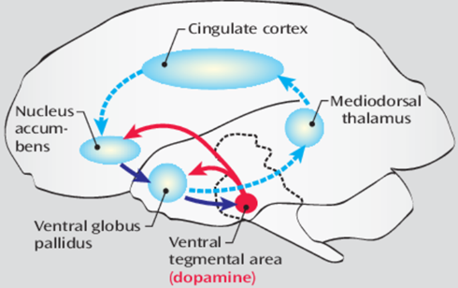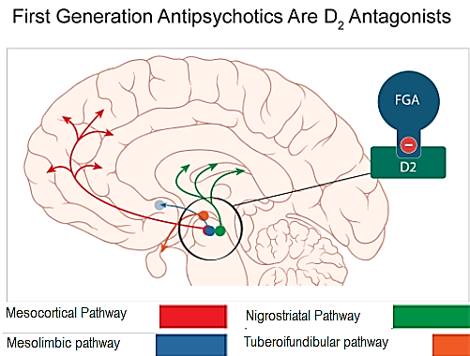
The mesocortical pathway decrease activity (dysfunction or Hypofunction) might be related to cognitive and negative symptoms of schizophrenia and is due to decrease dopamine or due to decrease number of dopamine receptor (D2) of the mesocortical pathway
The nigrostriatal system
The nigrostriatal system contains about 80% of the brain’s dopamine.
The nigrostriatal system projects from cell bodies in the pars compacta of the substantia nigra to terminals that innervate the striatum (caudate and putamen).
The nigrostriatal system is involved in motor planning, dopaminergic neurons stimulate purposeful movement.
The tuberoinfundibular pathway
Dopaminergic projections in the tuberoinfundibular pathway influence prolactin release.
The relation of Dopamine hypothesis of schizophrenia to First-generation antipsychotics are also known as: typical, conventionalتقليدي, dopamine antagonists, neuroleptics and classic antipsychotics
Antipsychotic (or major tranquilizers) are NOT curative and do NOT eliminate the chronic thought disorder but they often decrease the intensity of hallucination and delusion and permit the person with schizophrenia to function in supportive environment
The term "neuroleptic" refers to the ability of a drug to cause a syndrome known as “neurolepsis”. This syndrome has three main features: Psychomotor slowing, Emotional quieting الهدوء العاطفي, Affective indifferenceخمول المشاعر, apathyاللامبالاة, Anhedoniaانعدام التلذذ amotivation, and social withdrawal) “neurolepsis,” meaning slow or absent motor movement
The first antipsychotic drugs were discovered by accident in the 1950s when a drug with antihistamine properties (chlorpromazine) was serendipitously بضربة حظobserved to have antipsychotic effects
Typical antipsychotics that are effective in the treatment of schizophrenia have in common the ability to inhibit the dopaminergic system by blocking action of dopamine through their ability to block dopamine D₂ receptors in the brain.
Effects of block dopamine receptors by the first antipsychotic drugs
1. The mesolimbic pathway over activity decrease number of dopamine receptor (D2) at the ventral limbic area of striatum known as the nucleus accumbens reduces hyperactivity in this pathway and thereby
a. reduces positive symptoms
b. block reward mechanisms, leaving patients apathetic, anhedonic, lacking motivation, interest, and joy from social interactions, a state very similar to that of negative symptoms of schizophrenia or “neurolepsis”
2. The mesocortical pathway further reduce activity(hypoactivity) & number of dopamine receptor (D2) at prefrontal cortex further reduce activity in this pathway and thus not only not improve negative symptoms but actually potentially worsen them
3. The nigrostriatal system decrease number of dopamine receptor (D2) at dorsal (motor) striatum pseudo-parkinsonism (extrapyramidal symptoms because nigrostriatal system is part of extrapyramidal system and tardive dyskinesia).
Long-term blockade of D₂ receptors in the nigrostriatal dopamine pathway can cause upregulation of those receptors, which may lead to a hyperkinetic motor condition known as tardive dyskinesia, characterized by facial and tongue movements (e.g., tongue protrusions, facial grimaces, chewing) as well as quick, jerky limb movements. This upregulation may be the consequence of the neuron's futile attempt to overcome drug-induced blockade of its dopamine receptors.
A rare but potentially fatal complication called the “neuroleptic malignant syndrome,” associated with extreme muscular rigidity, high fevers, coma, and even death, and possibly related in part to D₂ receptor blockade in the nigrostriatal pathway
4. The tuberoinfundibular pathway decrease number of dopamine receptor (D2) at pituitary gland hyperprolactinemia (galactorrhea) and amenorrhea.
For conventional antipsychotics it is assumed that the 80% of D2 receptors is blocked in all brain areas.
This will explain why the Typical antipsychotics has therapeutic effect (1) and adverse effect (2&3&4)
Typical antipsychotics has varying degrees blockade of
M₁-cholinergic receptors have weak anticholinergic properties such as dry mouth, blurred vision, constipation, and drowsiness.
histamine H₁ receptors causing weight gain and drowsiness
α₁-adrenergic receptors causing CVS side effects such as orthostatic hypotension and drowsiness
B. Serotonin hypothesis of schizophrenia:
Evidence:
The serotonin (5-HT) hypothesis of schizophrenia arose from early studies on interactions between the two major classes of psychedelic hallucinogens, the indoleamines (e.g., lysergic acid diethylamide (LSD) and phenethylamines (e.g. mescaline), are mostly 5-HT_{2A} agonists that result in visual hallucinations and delusions
Pathway:
First:
Serotonin projections from the raphe nucleus
Second:
released in the cortex where it binds:
a. 5HT_{2A} receptors make a synaptic connection with glutamatergic pyramidal neurons, causing activation of the glutamatergic neuron. Activation of glutamatergic pyramidal neurons leads to glutamate release in the brainstem, which in turn stimulates GABA release. GABA binds to dopaminergic neurons inhibiting dopamine release at the neurons release dopamine
b. 5HT_{1A} receptors make axoaxonic connections with glutamatergic pyramidal neurons, causing inhibition of the glutamatergic neuron. If glutamate is not released from glutamatergic pyramidal neurons into the brainstem, then GABA release is not stimulated and in turn cannot inhibit dopamine release
If blocking 5HT_{2A} receptors increase dopamine in prefrontal cortex (is like taking your foot off the brake) reducing negative & extrapyramidal symptoms and hyperprolactinemia
توقيف ( 5HT2A) الذي يقلل الدوبامين لان نفي النفي اثبات
if stimulating 5HT_{1A} receptors increase dopamine is like stepping on the accelerator,
تحفز5HT1Aالذي يزيد الدوبامين
this why both actions that release dopamine might be additive.
Third:
GABA binds to dopaminergic neurons projecting from the substantia nigra to the striatum, inhibiting dopamine release. The revers is also true.
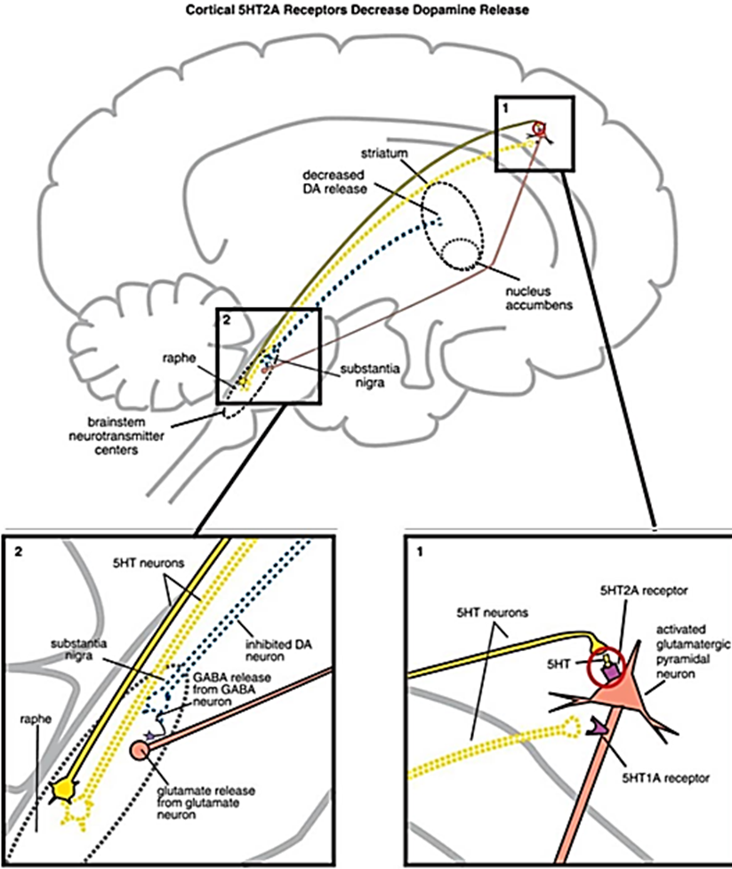
The relation of Serotonin-Dopamine hypothesis of schizophrenia to Second-generation antipsychotics or atypical or dopamine-serotonin antagonists antipsychotics
All second-generation antipsychotics can lower dopamine (by block D2 receptor in mesolimbic system) but why It is atypical because have the clinical profile of equal positive symptom antipsychotic actions, but low extrapyramidal symptoms and less hyperprolactinemia compared to conventional antipsychotics.
In psychosis there is upregulated 5-HT_{2A}receptors on glutamate neurons in prefrontal cortex
It has serotonin 5HT_{2A} receptor antagonism that accompanies D₂ receptor antagonism
It has a higher affinity to 5HT_{2A} receptor but lower affinity to D₂ receptor (high 5-HT2/D2 ratio) than first generation antipsychotics
It binds to D2 receptors
A. Loosely to D2 receptors: rapid dissociation from D2 receptors so, increase chance for dopamine to bind D2 receptor, while first-generation agents bind tightly to D2 receptors. This would be a possible explanation for the lower risk of extrapyramidal symptoms
B. Partially to D2 receptors: Some antipsychotics act to stabilize dopamine neurotransmission in a state between silent antagonism and full stimulation/agonist action by acting as partial agonists at D₂ receptors
some of second-generation antipsychotics are 5HT1A agonists (ziprasidone, quetiapine and clozapine)
5HT1A agonism would increase dopamine release in the prefrontal cortex and also reduce glutamate release and properties antianxiety and antidepressant
antipsychotic action is associated with adaptive modifications that involve changes in intracellular signal transduction and gene expression in target neurons. These changes appear to be initiated by binding to dopaminergic, serotonergic, muscarinic, adrenergic and other receptors. Most of these receptors belong to the G-protein-coupled receptors family. Downstream effectors include:
- Adenylate cyclase
- Various ion channels
- Phospholipases
- cAMP
- cAMP dependent kinase
- Protein kinase C, Protein lipase C
positron emission tomography show that D2 receptor occupancy predicts both clinical efficacy and extrapyramidal symptoms.
with lower risk of EPS and with higher risk of metabolic side effects.
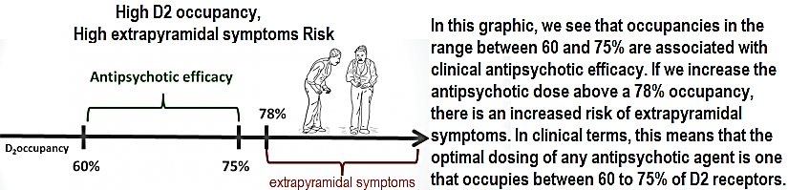
both first- and second-generation antipsychotics can block muscarinic-1, histamine-1 and alpha-1 receptors, among others
NOTE:
Dopamine NOT decrease drastically because atypical antipsychotic block D2 (partially, loosely and 60% NOT 80%) and slight increase in dopamine due to 5TH 2A antagonist and 5TH1A agonist
This balance between partial decrease and partial increase in dopamine will lower the risk of side effect where dopamine decreases drastically by typical antipsychotic and increase the possibility of complications
This why
a. It has the clinical profile of equal positive symptom antipsychotic actions
b. It has low extrapyramidal symptoms because 5HT2A antagonism can increase dopaminergic neurotransmission in the nigrostriatal pathway, reducing the risk of extrapyramidal symptoms and with higher risk of metabolic side effects (hyperglycemia, weight gain and dyslipidemia)
c. It could also theoretically improve negative and cognitive symptoms in schizophrenia by increasing dopamine release in the prefrontal cortex.
d. It has less hyperprolactinemia compared to conventional antipsychotics
B. Glutamate (or N-methyl-D-aspartate (NMDA) receptor hypofunction) hypothesis of schizophrenia
Psychotomimetic agent’s (chemical agents that reliably and dose-dependently induce a psychosis) phencyclidine (PCP) and ketamine induce negative and cognitive symptoms of schizophrenia, as well as positive symptoms similar to those of schizophrenia by blocking a type of glutamate receptor known as N-methyl-D-aspartate.
Treatment studies with N-methyl-D-aspartate (NMDA) receptor modulators (glutamate modulators) are a new form of antipsychotic, such as glycine, d‐serine, and glycine transport inhibitors (GTIs), have yielded encouraging findings, although results remain controversial
An important descending glutamatergic pathway projects from cortical pyramidal neurons to dopamine neurons in the ventral tegemental area.
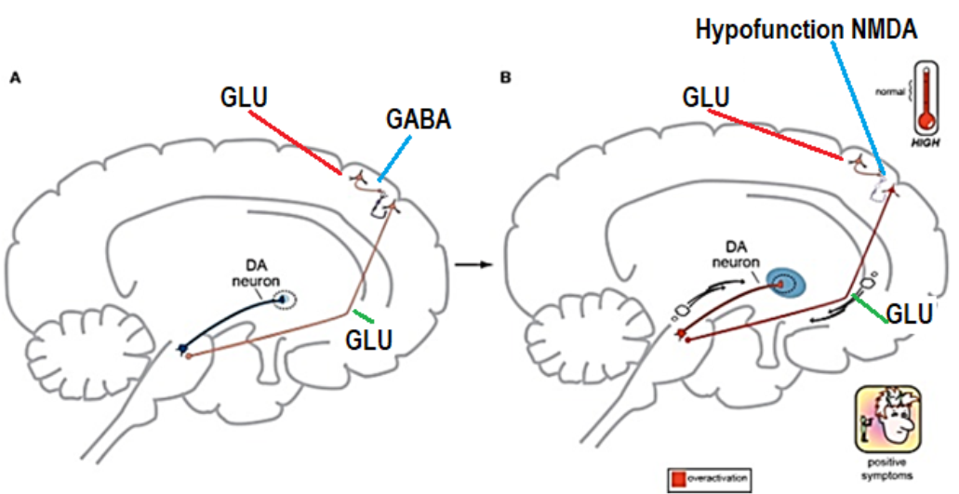
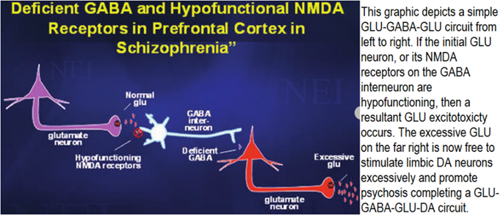
A. Positive symptoms of schizophrenia in the mesolimbic pathway:
May be the result of
a. No initial glutamate
b. hypo-functional NMDA receptors on GABA interneurons in the cerebral cortex.
Normally: GLU-GABA-GLU-DA: (+) – (-) – (+) ►↓ dopamine
Schizophrenia: GLU-zero-GLU-DA: (+) – (zero) – (+) ►↑ dopamine
This hypofunction may lead to over activation of downstream glutamate signaling to the ventral tegmental area. Over activation of this pathway may result in turn in excess dopamine in the ventral striatum via the mesolimbic pathway ►↑ positive symptoms of schizophrenia in the mesolimbic pathway
B. Negative symptoms of schizophrenia in the mesocortical pathway:
The circuit has changed from GLU-GABA-GLU-DA to one of GLU-GABA-GLU-GABA-DA and it has an extra step. May be the result of
First: a. No initial glutamate, b. hypo-functional NMDA receptors on GABA interneurons in the cerebral cortex.
Second:
Extra GABA interneurons
Normally: GLU-GABA-GLU-DA: (+) – (-) – (+) ►↓ dopamine
Schizophrenia: GLU-zero-GLU-GABA-DA: (+) – (zero) – (+) – (-) ►↓ dopamine
Low activation of this pathway may result in turn in low dopamine in the ventral striatum via the mesocortical pathway ►↑ negative symptoms of schizophrenia in the mesocortical pathway
Anxiety
Anxiety is an emotional state commonly caused by the perception of real or perceived danger that
threatens the security of an individual.
القلق هو حالة عاطفية ناتجة عادة عن إدراك ان هناك خطر الحقيقي أو بوجود خطر الذي يهدد أمن الفرد.
Anxiety allows a person to prepare for or react to environmental changes.
يسمح القلق للشخص بالاستعداد ل اي تغيرات البيئية أو المحيط والتفاعل معها.
Anxiety can produce
uncomfortable and potentially debilitating psychological (e.g., worry or feeling of threat)
الشعور بعدم الراحة ويمكن أن يكون منهكًا نفسيًا (على سبيل المثال ، القلق أو الشعور بالتهديد)
physiologic arousal (e.g., tachycardia or shortness of breath)
الاستثارة الفسيولوجية (مثل عدم انتظام دقات القلب أو ضيق التنفس)
if it becomes excessive.
Some individuals experience persistent, severe anxiety symptoms and possess irrational fears that
significantly impair normal daily functioning. These persons often suffer from an anxiety disorder.
يعاني بعض الأفراد من أعراض قلق شديدة وبصورة مستمرة ولديهم مخاوف غير عقلانية تضعف بشكل كبير الأداء اليومي الطبيعي. غالبًا ما يعاني هؤلاء الأشخاص من القلق.
Anxiety disorders are among the most frequent mental disorders )34% of the population (encountered in clinical practice and are often underdiagnosed and undertreated.
Healthcare professionals often mistake anxiety disorders for physical illnesses, and only one quarter of patients receive appropriate treatment.
Failure to diagnose and manage anxiety disorders results in negative outcomes including
overuse of healthcare resources,
increased risk for suicide
increased risk for substance abuse.
Individuals with anxiety disorders develop cardiovascular, cerebrovascular, gastrointestinal (GI), and respiratory disorders at a significantly higher rate than the general population.
To treat anxiety appropriately,
the clinician must make a reliable diagnosis
distinction between short-term symptoms of anxiety and anxiety disorders
Everyone experiences a certain amount of nervousness and apprehension (short-term symptoms of anxiety (; when faced with a stressful situation. This is an adaptive response and is transient in nature.
اي شخص طبيعي قد يعاني من قدر معين من القلق والخوف عند مواجهة اي الوضع مقلق.
ان هذه هي استجابة تكيفية طبيعية وعابرة في طبيعتها
Although symptoms can be severe, they are temporary and usually last no more than 2 or 3 weeks. Although short-term, “as-needed” treatment with an anxiolytic agent such as a benzodiazepine is common and can provide some symptomatic relief, prolonged drug therapy is not recommended for situational anxietyالضرف او الموقف(occurs during new situationsقبول الجامعة او وضيفة جديدة ,changing eventsالوقوف في اماكن مزدحمة او ضيقة, unfamiliar situations طلب التكلم امام الكاميراor events that make us so nervous that we lose control of our ability to stay calm).
Etiology:
Medical Diseases Associated with Anxiety
Anxiety disorders are associated with
chronic medical illness,
low levels of physical health-related quality of life (QOL), and
physical disability.
If anxiety symptoms are secondary to a medical illness, they usually will subside as the medical situation stabilizes.
Psychiatric Diseases Associated with Anxiety
Anxiety can be a presenting feature of several major psychiatric illnesses.
Anxiety symptoms are extremely common in patients with mood disorders, schizophrenia, dementia, and substance-use disorders.
Drug-Induced Anxiety
Drugs are a common cause of anxiety symptoms
Pathophysiology:
Neurochemical Theories
Noradrenergic Model
An anxiogenic or panicogenic substance is one that causes anxiety
An anxiolytic (also anti-panic or antianxiety) agents, which inhibits anxiety.
The basic premise of the noradrenergic theory is that the autonomic nervous system of anxious
patient is hypersensitive and overreacts to various stimuli.
In response to threat or fearful situations,

the locus ceruleus serves as an alarm center, activating norepinephrine release

stimulating the sympathetic and parasympathetic nervous systems.
Example 1
Drugs with anxiogenic effects (e.g., yohimbine [an α2-adrenergic receptor antagonist])

stimulate locus ceruleus firing and increase noradrenergic activity.

Norepinephrine in turn increases glutamate release (an excitatory neurotransmitter)

This produces subjective feelings of anxiety and can precipitate a panic attack in those with panic disorder, but not in normal volunteers.
Example 2
Drugs with anxiolytic a drug or anti-panic effects (e.g., benzodiazepines and antidepressants)

inhibit locus ceruleus firing,

decrease noradrenergic activity, and block the effects of anxiogenic drugs
GABA-Receptor Model
GABA, the major inhibitory neurotransmitter in the CNS, has a strong regulatory or inhibitory effect on the serotonin Norepinephrine, and dopamine systems. When GABA binds to the GABA_{A} receptor, neuronal excitability is reduced.
The specific role of the GABA receptors in anxiety disorders has not been established. The number of
GABA_{A} receptors can change with alterations in the environment (e.g., chronic stress), and the subunit
expression can be altered by hormonal changes
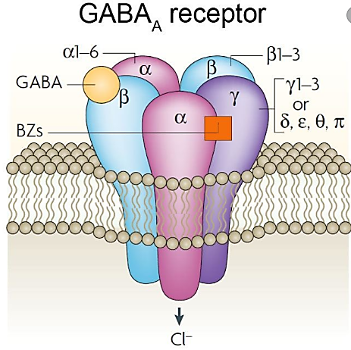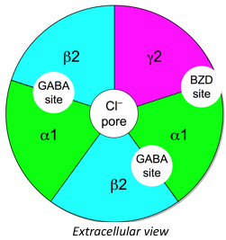
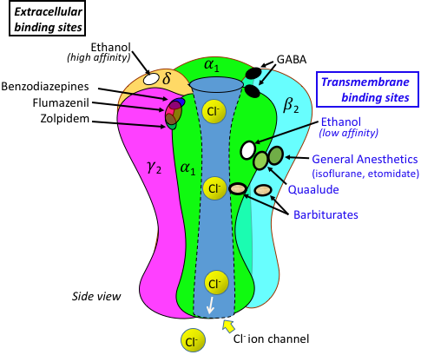
Serotonin Model
Although there are data suggesting that the Serotonin system is dysregulated in patients with anxiety
disorders, definitive evidence that shows a clear abnormality in Serotonin function is lacking.
Serotonin is primarily an inhibitory neurotransmitter that is used by neurons originating in the raphe nuclei of the brain stem and projecting diffusely throughout the brain (e.g., cortex, amygdala, hippocampus, and limbic system).
Primate studies show that reducing serotonin increases aggression.
It is postulated that greater Serotonin activity

reduces Norepinephrine activity in the locus ceruleus,

a. inhibits defense/escape response via the periaqueductal gray (PAG) region
b. reduces hypothalamic release of corticotropin-releasing factor.
Abnormalities in serotonergic functioning
A. through release and uptake at the presynaptic auto-receptors (5-HT1A/1D), the serotonin-reuptake transporter (SERT) site,
The selective serotonin reuptake inhibitors (SSRIs) acutely increase Serotonin levels by blocking the serotonin reuptake transporter to increase the amount of Serotonin available postsynaptically and are efficacious in blocking the manifestations of panic and anxiety.
B. the effect of Serotonin at the postsynaptic receptors (e.g. 5-HT1A, 5-HT2A, and 5-HT2C)
may play a role in anxiety disorders.
Low Serotonin activity may lead to a dysregulation of other neurotransmitters.
1. Norepinephrine and Serotonin systems
Norepinephrine and Serotonin systems are closely linked
Norepinephrine and Serotonin systems interactions are reciprocal and vary:
norepinephrine may act at presynaptic Serotonin terminals to decrease Serotonin release
norepinephrine activity at postsynaptic receptors can cause increased Serotonin release.
2. Dopamine and serotonin system:
There is circumstantial evidence for the involvement of serotonergic and dopaminergic systems in the
pathophysiology of generalized social anxiety disorder.
Generalized anxiety disorder
Risk factors
Women are diagnosed with generalized anxiety disorder somewhat more often than men are.
The following factors may increase the risk of developing generalized anxiety disorder:
Personality. A person whose temperament is timid مزاجه خجول or negative or who avoids anything dangerous may be more prone to generalized anxiety disorder than others are.
Genetics. Generalized anxiety disorder may run in families.
Experiences. People with generalized anxiety disorder may have a history of significant life changes, traumatic or negative experiences during childhood, or a recent traumatic or negative event.
Chronic medical illnesses or other mental health disorders may increase risk.
Diagnostic Criteria for Generalized Anxiety Disorder
A. Excessive anxiety and worry (apprehensive expectation), occurring more days than not for at least 6 months, about a number of events or activities (such as school performance, health issues, money, death, family problems, friendship problems, interpersonal relationship problems, or work difficulties).
B. The individual finds it difficult to control the worry.
C. The anxiety and worry are associated with three (or more) of the following six symptoms (with at least some symptoms having been present for more days than not for the past 6 months):
Note: Only one item is required in children.
1. Restlessness or feeling keyed up or on edge.
2. Being easily fatigued.
3. Difficulty concentrating or mind going blank.
4. Irritability.
5. Muscle tension.
6. Sleep disturbance (difficulty falling or staying asleep, or restless, unsatisfying sleep).
D. The anxiety, worry, or physical symptoms cause clinically significant distress or impairment in social, occupational, or other important areas of functioning.
E. The disturbance is not attributable to the physiological effects of a substance (e.g., a drug of abuse, a medication) or another medical condition (e.g., hyperthyroidism).
F. The disturbance is not better explained by another mental disorder
Social anxiety disorder (SAD), also known as social phobia,
People with social anxiety typically know that their anxiety is irrational, is not based on fact, and does not make rational sense. Nevertheless, thoughts and feelings of anxiety persist and are chronic in nature.
The exact cause of social phobia is unknown. However, current research supports the idea that it is caused by a combination of environmental factors and genetics.
Negative experiences also may contribute to this disorder, including:
bullying
family conflict
sexual abuse
Diagnostic and statistical Manual of mental disorder 5TH Edition: (DSM-5) criteria for social anxiety disorder include:
Persistent, intense fear or anxiety
1. It is about specific social situations (such as Eating in front of other people, Speaking in public, Being the center of attention, Talking to strangers, Going on dates, Meeting new people, Interviewing for a new job, Going to work or school, Meeting other people’s eyes, Making phone calls in public, Using public restrooms)
2. It is because you believe you may be judged, embarrassed or humiliated yourself and be rejected by others
3. It is out of proportion to the actual threat of the situation.
4. It has lasted for 6 months or longer.
5. It causes significant distress or impairment in important areas of your life, such as your work or connections with others.
7. Its psychological, behavioral, or autonomic symptoms must be primarily manifestations of anxiety and cannot be attributed to the effects of a drug/medication, is not explained by another mental disorder such as delusions or obsessional thoughts, and is not related to a medical condition
8. It must be restricted to or predominate in particular social situations; and avoidance of the phobic situations must be a prominent feature.
Symptoms
An individual may experience physical, emotional, and behavioral symptoms of social anxiety disorder. These symptoms can significantly affect the individual’s daily life and relationships.
Physical Symptoms
- Rapid heartbeat
- Dizziness
- Muscle tension or twitches
- Stomach trouble
- Blushing
- Trembling
- Excessive sweating
- Dry throat and mouth
Emotional Symptoms
- High levels of anxiety and fear
- Nervousness
- Panic attacks
- Negative emotional cycles
- Dysmorphia concerning part of their body (most commonly the face)
person experiences excessive anxiety about a perceived defect in their physical appearance.
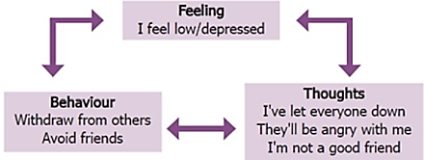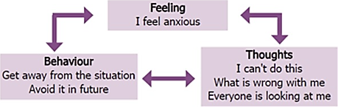
Behavioral Symptoms
- Avoiding situations where the individual thinks they may be the center of attention
- Refraining from certain activities because of a fear of embarrassment
- Becoming isolated; the individual may quit their job or drop out of school
- Excessive drinking or substance abuse

