Smell and taste
- Smell and taste are generally classified as visceral senses because of their close association with GIT function. Physiologically, they are related to each other.
- The flavors of various foods are in large part a combination of their taste and smell. Consequently, food may taste different if one has a cold that depresses the sense of smell.
- Both taste and smell receptors are chemo-receptors that are stimulated by molecules in solution in mucus in the nose and saliva in the mouth.
- These two senses are anatomically quite different:
Smell sensation | Taste sensation
1. The smell receptors are distance receptors (teleceptors) | 1. The taste receptors are NOT distance receptors
2. The smell pathways have no relay in the thalamus | 2. The taste pathways have relay in the thalamus

Smell
Olfactory epithelium
Olfactory epithelium covers an area of 5 cm2 in the roof of the nasal cavity near the septum
Olfactory epithelium contains odorant receptor (Olfactory sensory neurons).
Olfactory epithelium contains 10 to 20 million bipolar olfactory sensory neurons interspersed with glia-like supporting (sustentacular) cells and basal stem cells.
Olfactory sensory neurons has a short, thick dendrite that projects into the nasal cavity where it terminates in a knob containing 10 to 20 cilia. The cilia are unmyelinated processes contain specific receptors for odorants (odorant receptors).
Olfactory sensory neurons axons pass through the cribriform plate of the ethmoid bone and enter the olfactory bulbs
New olfactory sensory neurons are generated by basal stem cells as needed to replace those damaged by exposure to the environment; where this process is inhibited by bone morphogenic protein (BMP)
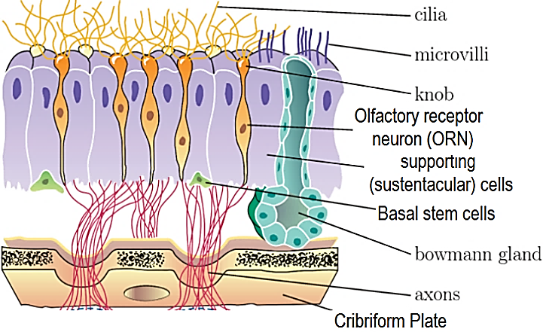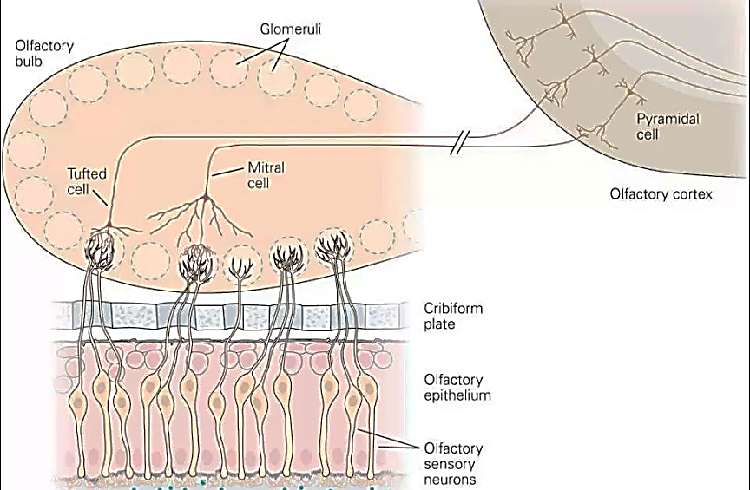
Olfactory bulbs
In the olfactory bulbs, the axons of the olfactory sensory neurons (first cranial nerve) contact the primary dendrites of the mitral cells and tufted cells to form anatomically discrete synaptic units called olfactory glomeruli.
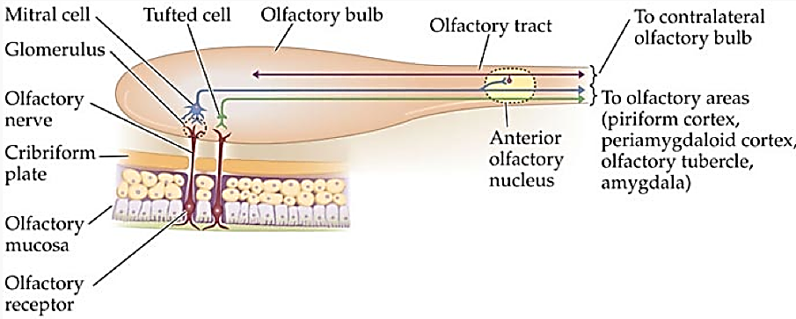
Olfactory cortex
Conscious discrimination of odors is dependent on the pathway to the orbitofrontal cortex.
The orbitofrontal activation is generally greater on the right side than the left; thus, cortical representation of olfaction is asymmetric.
The pathway to the amygdala is probably involved with the emotional responses to olfactory stimuli, and the pathway to the entorhinal cortex is concerned with olfactory memories.
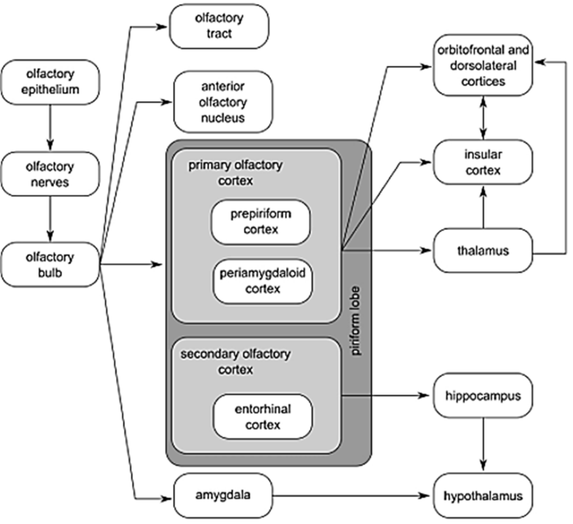
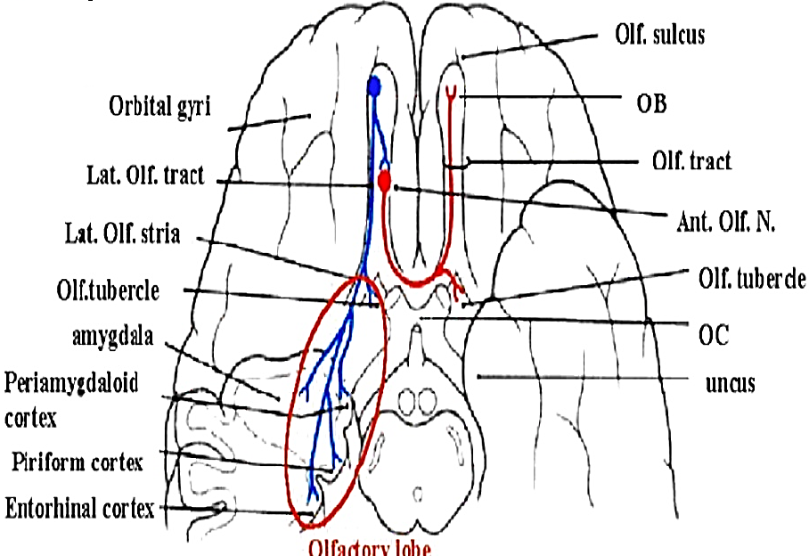
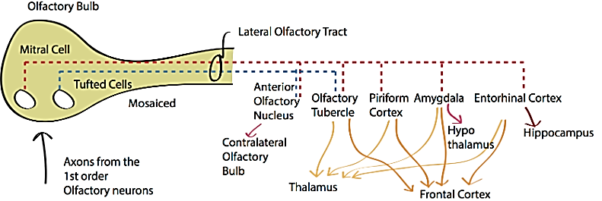
Signal transduction in an odorant receptor
The olfactory epithelium is covered by a thin layer of mucus secreted by the supporting cells and Bowman glands, which lie beneath the epithelium. The mucus bathes the odorant receptors on the cilia and provides the appropriate molecular and ionic environment for odor detection. The olfactory mucus might contain one or more odorant-binding proteins (OBP) that concentrate the odorants and transfer them to the receptors.
The concentration of an odor-producing substance must be changed by about 30% before a difference can be detected. The comparable visual discrimination threshold is a 1% change in light intensity.
The direction from which a smell comes may be indicated by the slight difference in the time of arrival of odoriferous molecules in the two nostrils.
Odor-producing molecules are generally small, containing from 3 to 20 carbon atoms, and molecules with the same number of carbon atoms but different structural configurations have different odors. Relatively high water and lipid solubility are characteristic of substances with strong odors.
The binding of an odorant molecule to an odorant receptor (OR) leads to the interaction of the receptor with a GTP-binding protein (G_{olf}). This interaction in turn leads to the release of ά GTP-coupled Gα_{olf} subunit, which then stimulates adenylyl cyclase III (ACIII) to produce elevated levels of cyclic AMP (cAMP). The increase in cyclic AMP opens cyclic nucleotide-gated (CNG) cation channels, allowing both Ca2+ and Na+ to enter the cell through the cilia. This causes a membrane depolarization, leading to an action potential transducing the signal to the olfactory bulb.
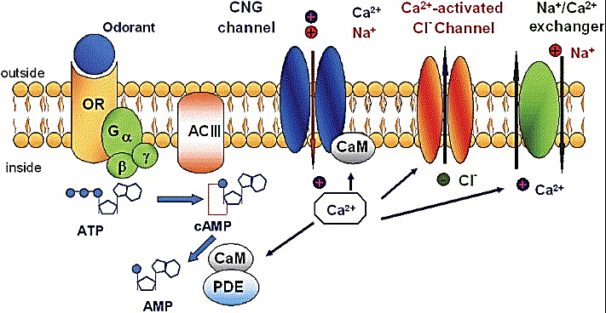
About 1000 different types of odorant receptors make up the largest gene family so far described in mammals; larger than the immunoglobulin and T-cell receptor gene families combined.
Increase cytoplasmic calcium opening ofCa2+-activated Cl− channel leading to Cl− efflux which further depolarizes the cell.
Inhibition of function:
a. Ca2+ binds to calmodulin stimulates the activity of a phosphodiesterase (PDE) lowering the cAMP sensitivity of the cyclic nucleotide-gated (CNG) cation channels lowering influx of Na and Ca . CaCl efflux
b. Ca2+ is extruded by a Na+/Ca2+ exchanger.
This is the explanation phenomenon of fairly rapid adaptation, or desensitization, which occurs in the olfactory system.
Sniffing
The portion of the nasal cavity containing the olfactory receptors is poorly ventilated in humans.
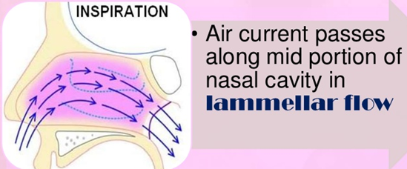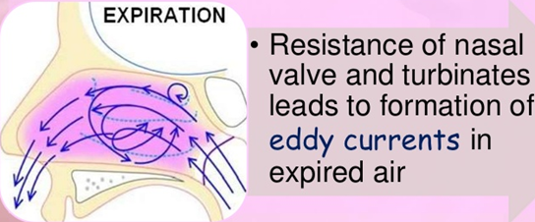
Most of the air normally moves smoothly over the turbinates with inspiration, Eddy currents pass some air over the olfactory epithelium during expiration.
These eddy currents are probably set up by convection as cool air strikes the warm mucosal surfaces or resistance of nasal valve and turbinates
The amount of air reaching this region is greatly increased by sniffing
Sniffing is a semi-reflex response that usually occurs when a new odor attracts attention.
Role of pain fibers in the nose:
Naked endings of many trigeminal pain fibers are found in the olfactory epithelium.
They are stimulated by irritating substances and leads to the characteristic “odor” of such substances as peppermint, menthol, ammonia and chlorine.
Activation of these endings by nasal irritants also initiates sneezing, lacrimation, respiratory inhibition, and other reflexes.
Abnormalities in Odor Detection
Anosmia (inability to smell) and hyposmia or Hypoesthesia (partial diminished olfactory sensitivity)
Anosmia can result from
A. Problems with the inner lining nose
Conditions that cause temporary irritation or congestion inside your nose may include:
Acute sinusitis (nasal and sinus infection), Common cold, Allergic rhinitis, Influenza (flu), Smoking
B. Obstructions of nasal passages
Conditions or obstructions that block the flow of air through your nose can include:
Deviated septum, Nasal polyps, tumors
C. Damage to brain or nerves
Nerves leading to the area of the brain that detects smell or the brain itself can be damaged or deteriorate due to:
Aging, Alzheimer’s disease, Brin surgery, Brain tumors, Diabetes, Exposure to toxic chemicals, such as pesticides or solvents, Certain medication, Cocaine abuse
Studies have shown that people who are unable to smell one or one class of odors frequently have small genetic differences from the general population.
"Hyperosmia," a heightened sense of smell, can be a genetic trait
Taste
Taste buds’ structure
The specialized sense organ for taste (gustation) consists of approximately 10,000 taste buds
Taste buds are ovoid bodies measuring 50–70 μm and composed of 50-100 taste cells each
There are four morphologically distinct types of cells within each taste bud:
Basal cells (Type I taste cells: Glial-like cells) ~3% of cells
The basal cells arise from the epithelial cells surrounding the taste bud.
The basal cells differentiate into new taste cells, and the old cells are continuously replaced with a half-time of about 10 days.
The basal cells act as support cells
Dark cells (Type I taste cells) 60% of cells
Light cells (Type II taste cells) 30% of cells, detect bitter, sweet and umami tastes
Intermediate cells (Type III taste cells) 7% of cells, detect sour and salty flavors
The three cell types may represent various stages of differentiation of developing taste cells, with the light cells being the most mature.
The apical ends of taste cells have microvilli that project into the taste pore, a small opening on the dorsal surface of the tongue where tastes cells are exposed to the oral contents.
Each taste bud is innervated by about 50 nerve fibers, and conversely, each nerve fiber receives input from an average of five taste buds.
In humans, the taste buds are located in the mucosa of the epiglottis, palate, and pharynx and in the walls of papillae of the tongue.
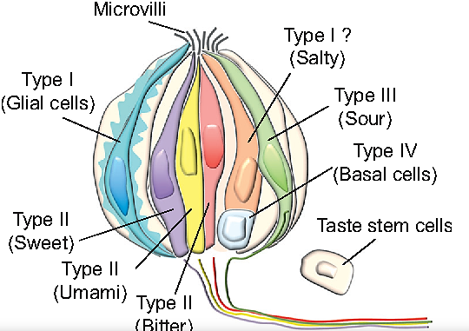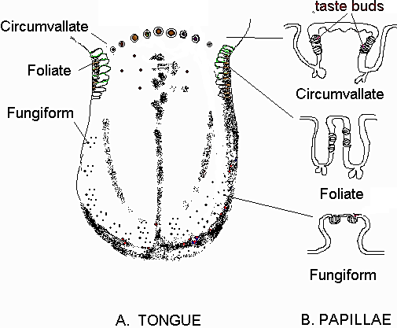
Types of taste buds:
1. The fungiform papillae: are rounded structures most numerous near the tip of the tongue; fewer in number, lightly keratinized and scattered taste buds
Each fungiform papilla has up to five taste buds, mostly located at the top of the papilla
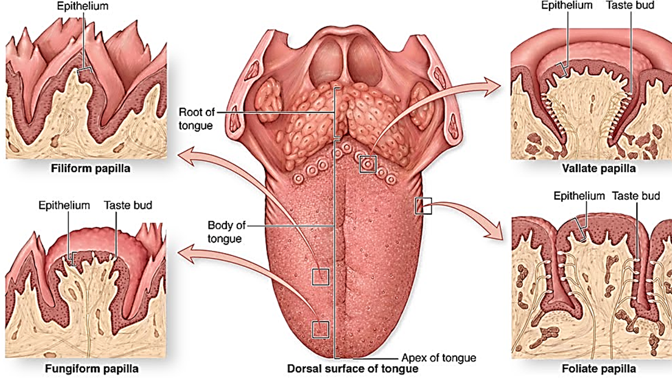
2. The circum-vallate (or vallate) papillae: are prominent structures arranged in a V on the back of the tongue
3. The foliate papillae: are on the posterior edge of the tongue.
4. The filform papillae: cover the majority of the anterior surface, highly keratinized and lack taste buds.
The filiform are the most abundant type of papillae found on the surface on the tongue.
Each vallate and foliate papilla contain up to 100 taste buds, mostly located along the sides of the papillae.
Taste pathway
First order neurons: the sensory nerve fibers from the taste buds
1. on the anterior two-thirds of the tongue travel in the chorda tympani branch of the facial nerve
2. on the posterior third of the tongue travel in the glossopharyngeal nerve
3. on the areas other than the tongue (pharynx, throat, palate) ravel in the vagus nerve
On each side, the myelinated but relatively slowly conducting taste fibers in these three nerves unite reach the brain stem in the gustatory portion of the nucleus of the solitary tract (NTS) in the medulla oblongata
From there, axons of second-order neurons ascend in the ipsilateral medial lemniscus and, in primates, pass directly to the ventral posteromedial nucleus of the thalamus.
From the thalamus, the axons of the third-order neurons pass to neurons in the anterior insula and the frontal operculum in the ipsilateral cerebral cortex. This region is rostral to the face area of the Post-central gyrus, which is probably the area that mediates conscious perception of taste and taste discrimination.
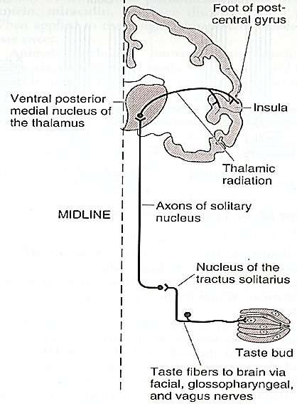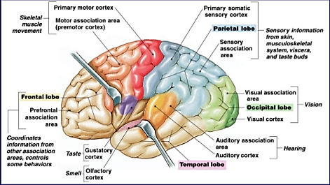
Basic taste modalities
Humans have five established basic tastes: sweet, sour, bitter, salt, and umami.
It used to be thought that the surface of the tongue had special areas for each of the first four of these sensations, but it is now clear that all tastants are sensed from all parts of the tongue and adjacent structures. Afferent nerves to the NTS contain fibers from all types of taste receptors, without any clear localization of types.

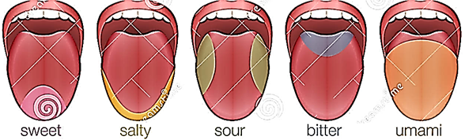
Taste receptors and transduction
1. The salty taste is triggered by NaCl.
Salt-sensitive taste is mediated by a Na⁺-selective channel known as amiloride-sensitive epithelial sodium channel (ENaC). The entry of Na+ into the salt receptors depolarizes the membrane, generating the receptor potential.
2. The sour taste is triggered by protons (H⁺ ions).
a. ENaCs permit the entry of protons and may contribute to the sensation of sour taste.
b. The H⁺ ions can also bind to and block a K⁺-sensitive channel (Kir2.1 inward-rectifier potassium ion channel). The fall in K⁺ permeability can depolarize the membrane.
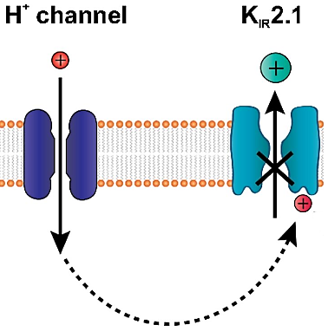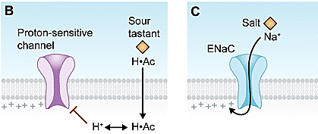
c. hyperpolarization-activated cyclic nucleotide-gated cation channel (HCN) is type of voltage gate potassium channel also found in cardiac and neural cells. HCN1 and HCN4 are expressed in a subset of taste cells. Strong acid will open potassium channel causing hyperpolarization
3. Bitter taste is produced by a variety of unrelated compounds.
Many of these are poisons, and bitter taste serves as a warning to avoid them.
a. Some bitter compounds bind to and block K⁺-selective channels.
b. Some bitter compounds are membrane permeable and may not involve G proteins; quinine is an example.
c. Some bitter compounds bind receptors couple to the heterotrimeric G protein, gustducin.
Gustducin.
Gustducin is a G protein associated with taste found in some taste receptor cells and the GIT.
Gustducin is known to play a large role in the transduction of bitter, sweet and umami stimuli
When bitter compounds taste molecules, bind taste GPCRs activate heterotrimeric GTP-binding proteins. For example, the bitter receptors (T2Rs: Taste receptor type 2) are co-expressed with and activate the taste-selective Gα subunit, α-gustducin, and the closely related α-transducin. The principal pathway for taste transduction appears to be via Gβγ. Upon ligand binding, the Gβγ subunits are freed from the taste GPCR and interact functionally with a phospholipase, PLCβ2. PLCβ2 stimulates the synthesis of IP₃, which opens IP₃R3 ion channels on the endoplasmic reticulum, releasing Ca²⁺ into the cytosol of receptor cells. The elevated intracellular Ca²⁺ appears to have two targets in the plasma membrane:
A. a taste-selective cation channel, Transient receptor potential cation channel subfamily M member 5 (TRPM5), non-selective cation channel that induces depolarization (by sodium influx) upon increases in intracellular calcium. The Ca²⁺-dependent opening of TRPM5 produces a depolarizing generator potential in receptor cells.
B. gap junction hemichannel: Pannexin-1(Panx1):
ATP, and possibly other molecules, are secreted through the hemichannel pores into the extracellular space surrounding the activated receptor cell
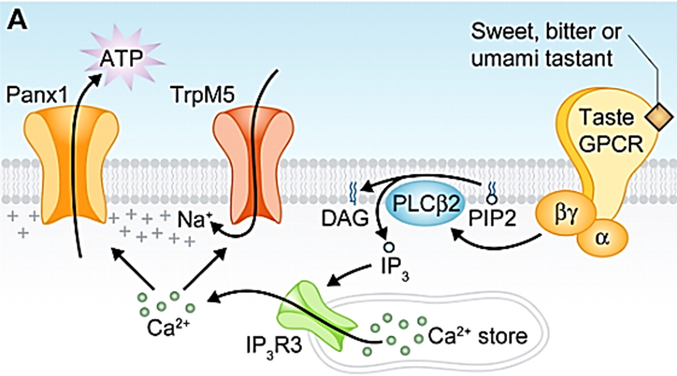
4. Umami taste is due to
Umami taste is elicited by L-glutamate and, to some extent, L-aspartate, it serves as a more general detector of L-amino acids and is thought to be initiated by G protein–coupled receptors (GPCRs). Proposed umami receptors include heterodimers of taste receptor type 1, members 1 and 3 (T1R1 + T1R3), and metabotropic glutamate receptors 1 and 4 (mGluR1 and mGluR4).
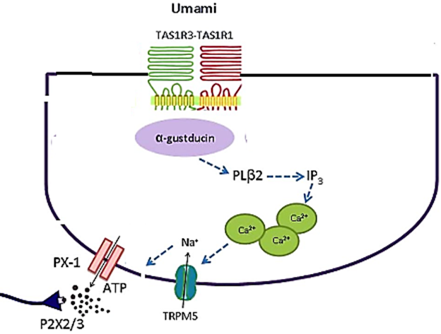
The GPCR mGluR1 main transduction pathway relies on the G protein Gq and phospholipase C (PLC), which elevates inositol 1,4,5-triphosphate (IP₃), with the subsequent release of Ca²⁺ from IP₃-dependent intracellular Ca²⁺ stores.
The GPCR mGluR1 other transduction cascades including adenylate cyclase, tyrosine kinase
5. Substances that taste sweet such as saccharin
They have an entirely different structure and act via the T1R2/3 family of G protein-coupled receptors gustducin, cyclic nucleotides and inositol phosphate metabolism.
Taste exhibits after reactions and contrast phenomena that are similar in some ways to visual after images and contrasts. Some of these are chemical “tricks,” but others may be true central phenomena. A taste modifier protein, miraculin, has been discovered in a plant. When applied to the tongue, this protein makes acids taste sweet.
